PROJECT REPORT ON

DJANGO USING PYTHON

**XXX COLLEGE OF ENGINEERING**

**Branch:**___

**Year:**___ ( ____ semester)

BOOK REVIEW PROJECT

**Prepared for:**

XX Department

Under the guidance of:

Ms. Deepa Ashok Kumar

**Prepared by:**

**Name_______________ , University Registration No- _____________**

**Table of Contents**

Acknowledgement

Abstract

Requirement Specification

Screenshots ..

Conclusion..............................................................................................................................................

**Acknowledgement**

I take this opportunity to express my profound gratitude and deep regards to my faculty for her exemplary guidance, monitoring and constant encouragement throughout the course of this project. The blessing, help and guidance given by her time to time shall carry me a long way in the journey of life on which I am about to embark.

I am obliged to my project team members for the valuable information provided by them in their respective fields. I am grateful for their cooperation during the period of my assignment.

(Project group member names)

**Abstract**

This project addresses the study of the emerging sector of website development, and its core features that are used by most of the websites running today.

The main goal is to develop an accessible and user friendly platform for users who wants to know about books of different categories from a single platform with choices from similar other books of the same category. In case the user wants to know about the author of a book, he can do so from the website. The user can browse through different categories from homepage , by shortcut links provided on homepage , but if they want to comment on a review of a book, they have to signup/login through a very simple procedure . The user will find the direct buying link for every book. The user can give feedback about the website by filling up the feedback form.

**Requirement Specification**

*  Text editor software and local server installation :
* Details about the software requirement
* Download and installation process
* Download and installation of Python, Django, Notepad++
* Setting up database and creating database connections
* HTML Layouts :
* Div containers
* Form fields
* Tables
* Buttons

* CSS Designing :
*  Navigation bar
* Footer
* Social media icons
* Background images
* Div containers
* Buttons, Fields
* JAVASCRIPT Used :
* Validations on signup and login pages
* Alert boxes
* Datepicker
* DJANGO Used :
* Connecting database
* Passing and retrieving values from database
* Server and Client side validations
* Displaying profile details
* Search
* Sessions

**SCREENSHOTS:**

* HOMEPAGE ( ‘HOME’ FROM THE NAVIGATION BAR ) :

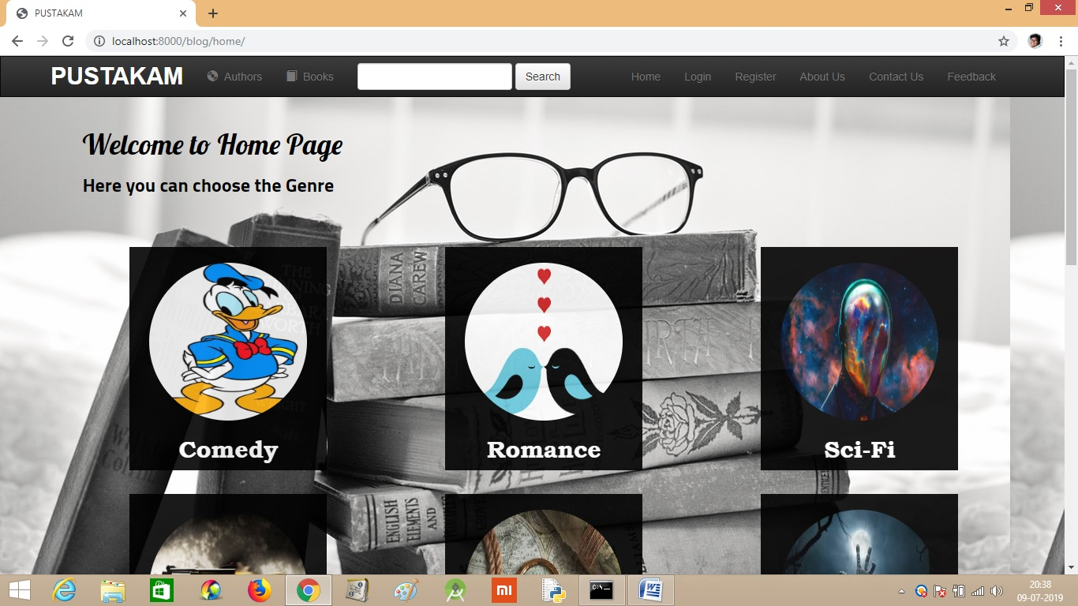

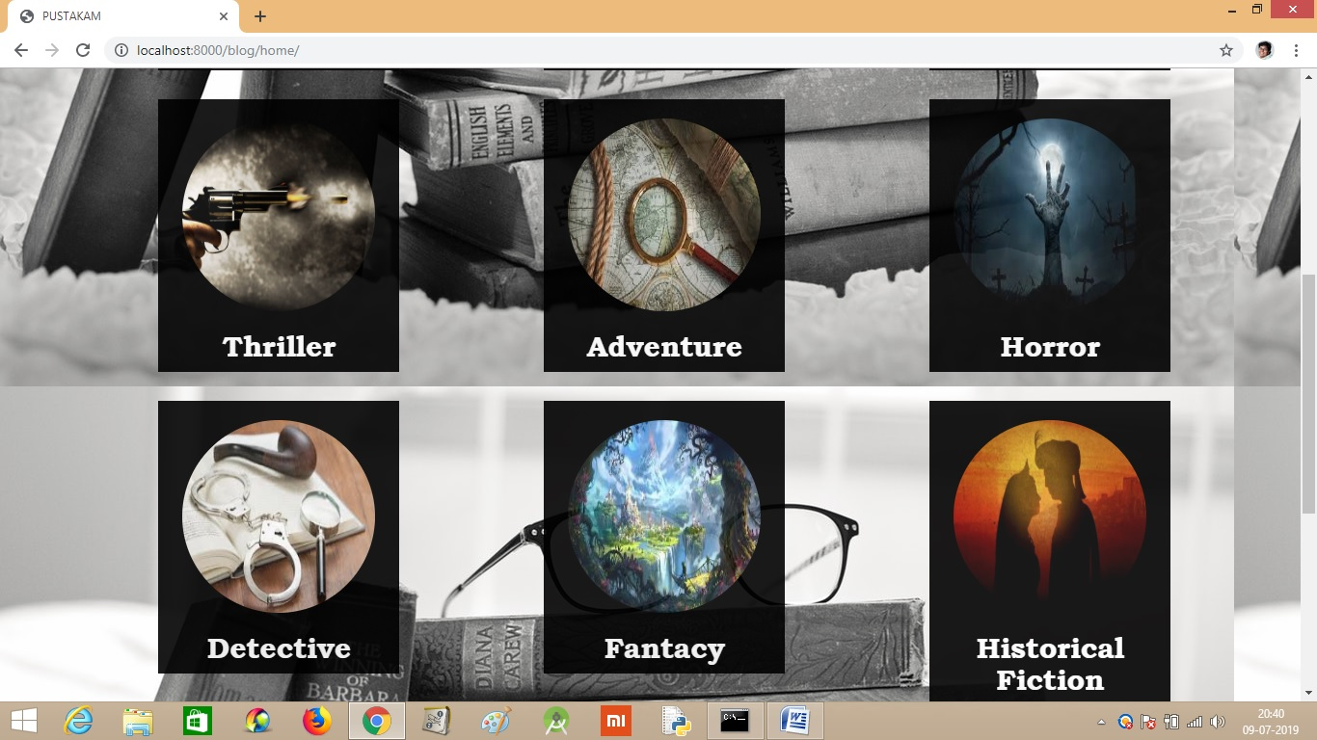

* CLICKING ON THE ‘REGISTER’ FROM NAVIGATION BAR :

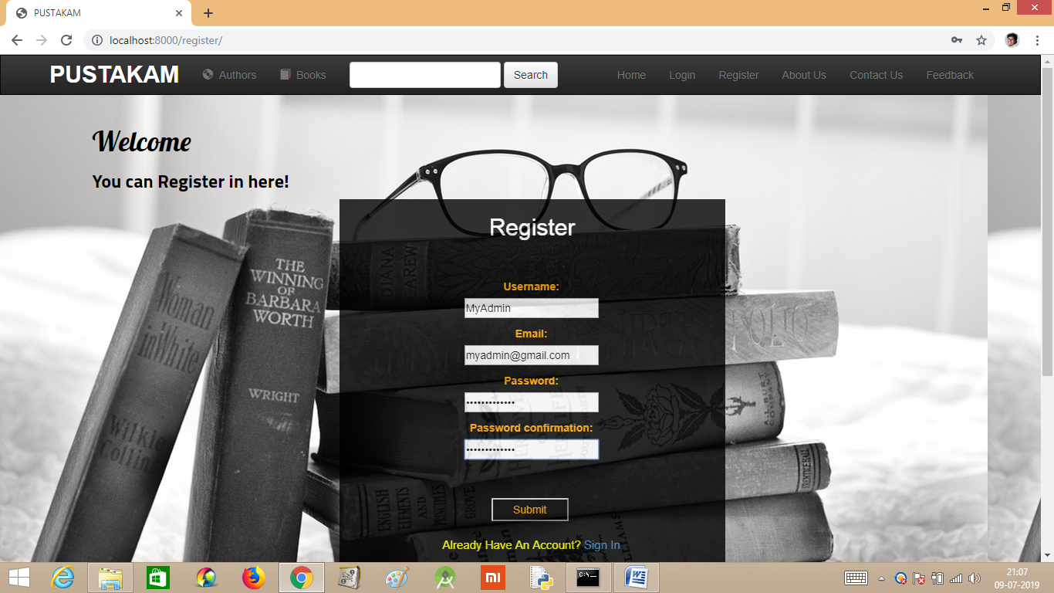

* CLICKING ON ‘LOGIN’ FROM THE NAVIGATION BAR ( FOR NEW USERS AFTER DOING REGISTER LOGIN WILL BE REDIRECTED ) :

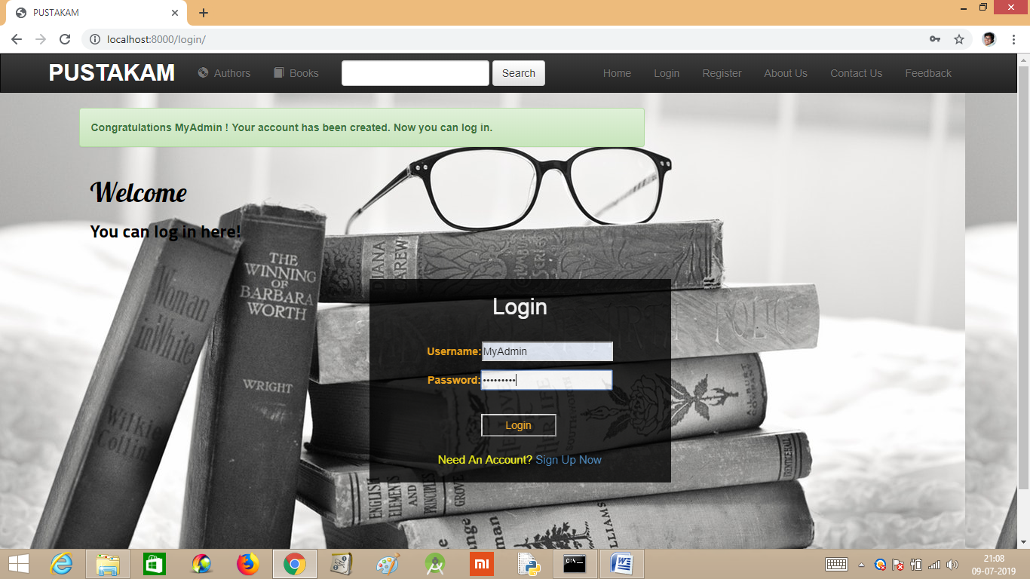

* CLICKING ON THE ‘PROFILE’ FROM THE NAV BAR AND UPDATING THE PROFILE PICTURE FROM UPDATE PROFILE INFO :

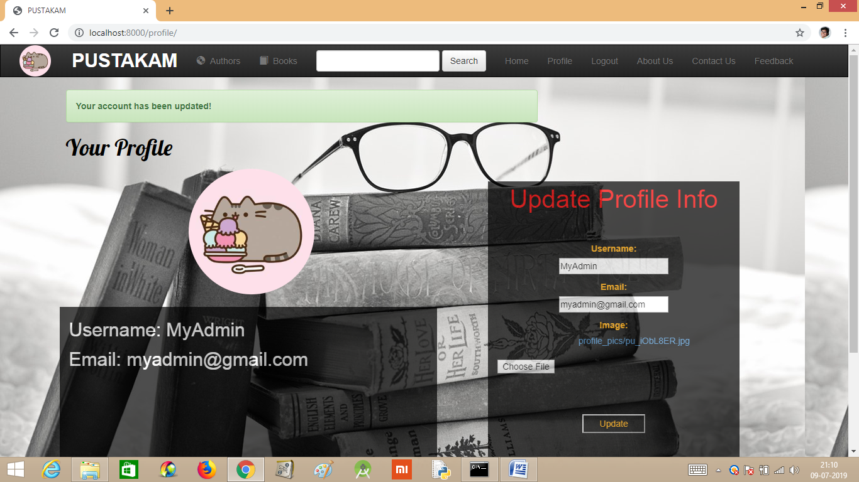

* AFTER SELECTING A GENRE FROM HOMEPAGE :



* GOING TO THE ‘BOOKS’ FROM THE NAVIGATION BAR, IT WILL SHOW THE LIST OF ALL BOOKS :

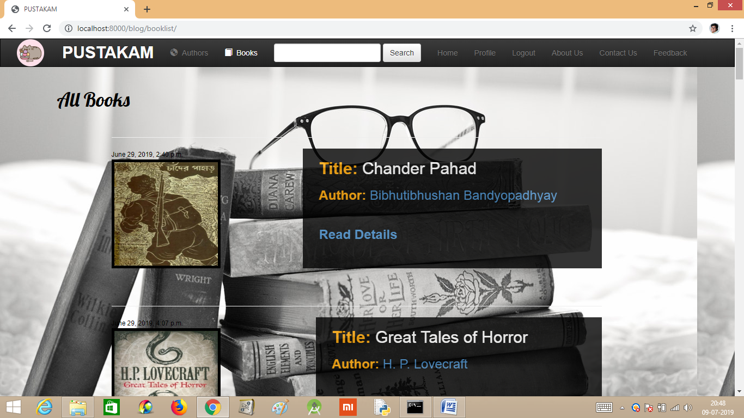

* CLICKING ON ‘READ DETAILS’ OF A BOOK :

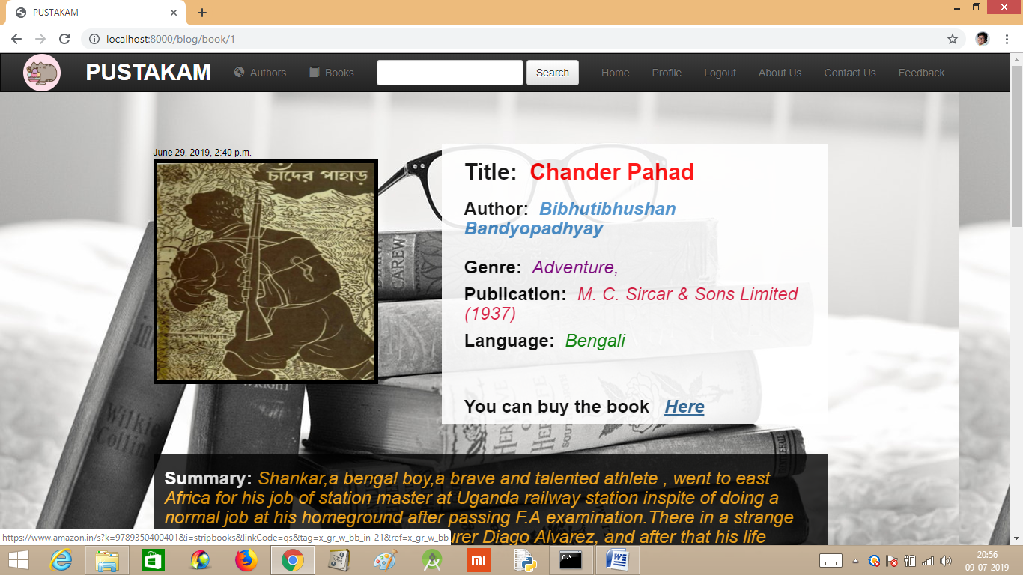

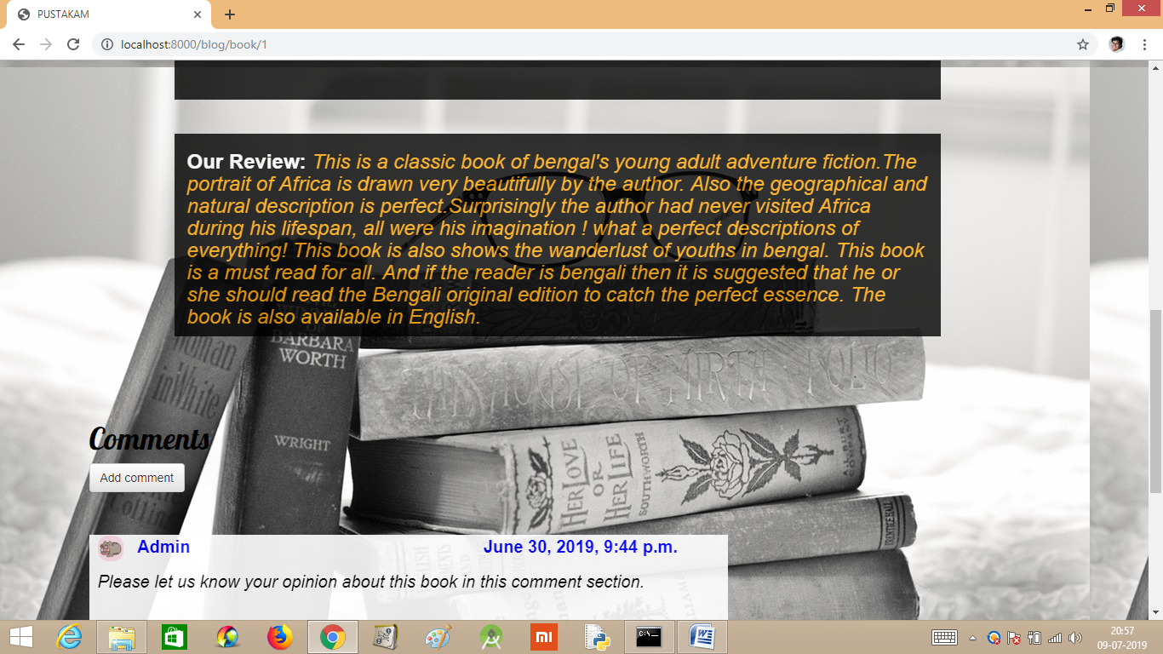

* CLICKING ON ADD COMMENT :

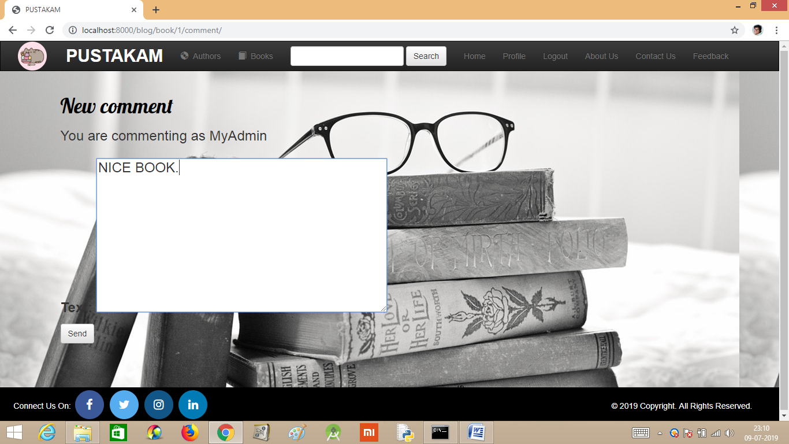

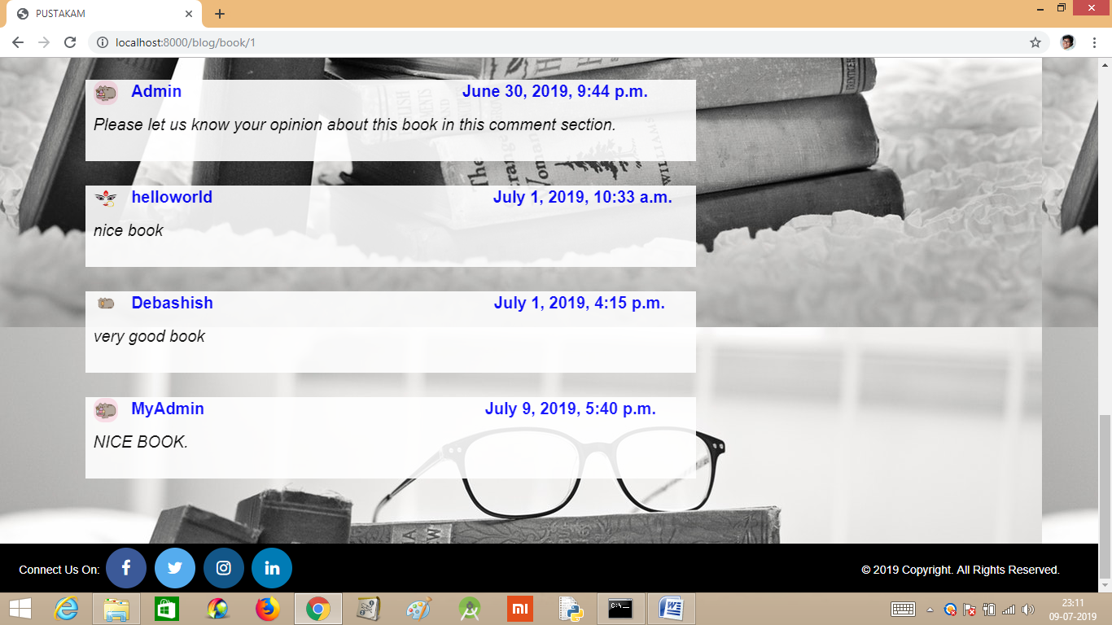

* GOING TO THE ‘AUTHORS’ FROM NAVIGATION BAR , IT WILL SHOW THE LIST OF ALL AUTHORS :

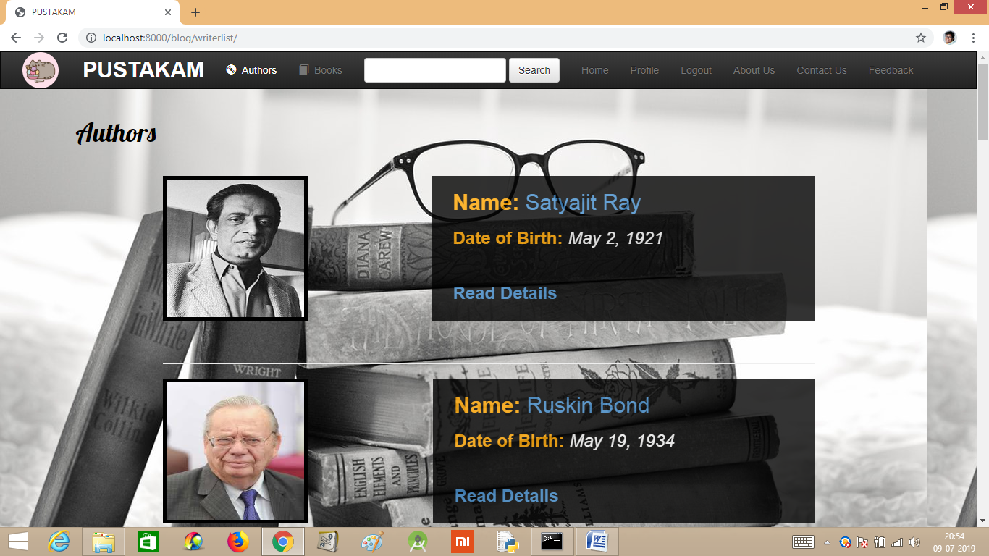

* CLICKING ON ‘READ DETAILS’ OF AN AUTHOR :

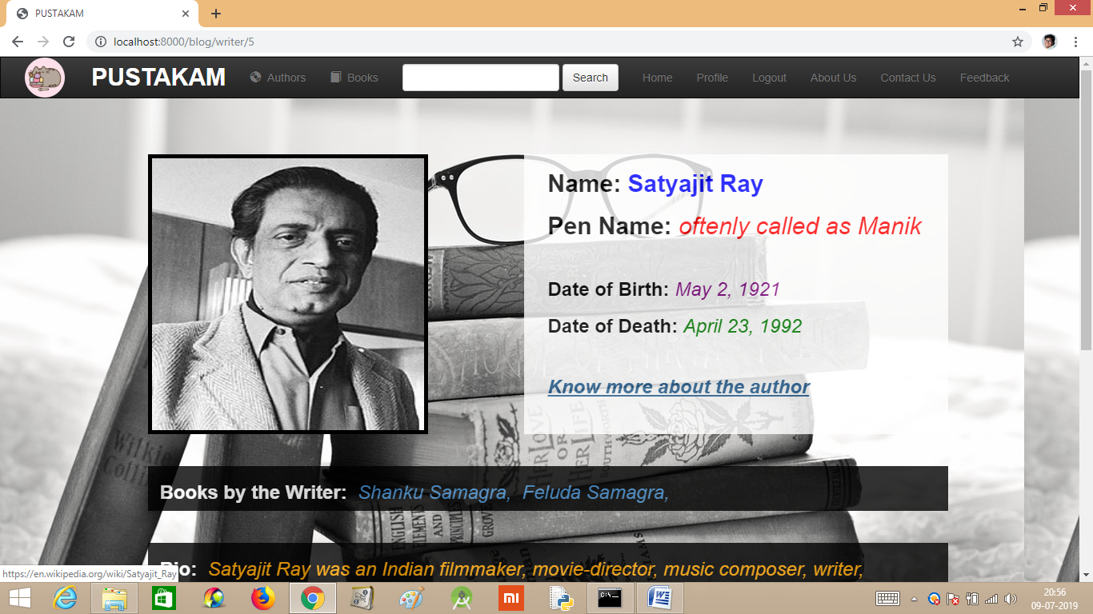

* ‘SEARCH’ OPERATION FROM THE NAVIGATION BAR :

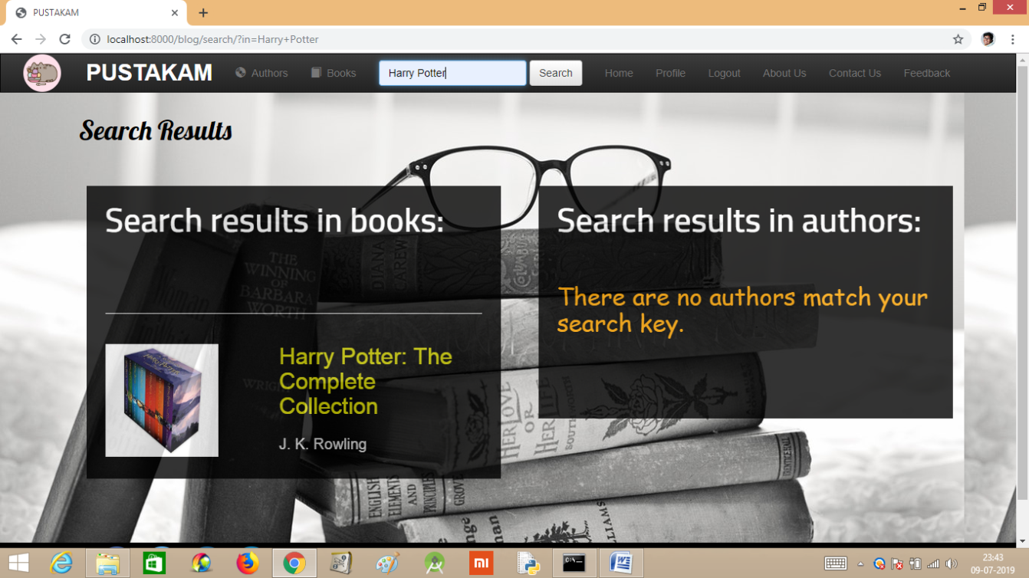

* GOING TO THE ‘ABOUT US’ FROM NAVIGATION BAR :

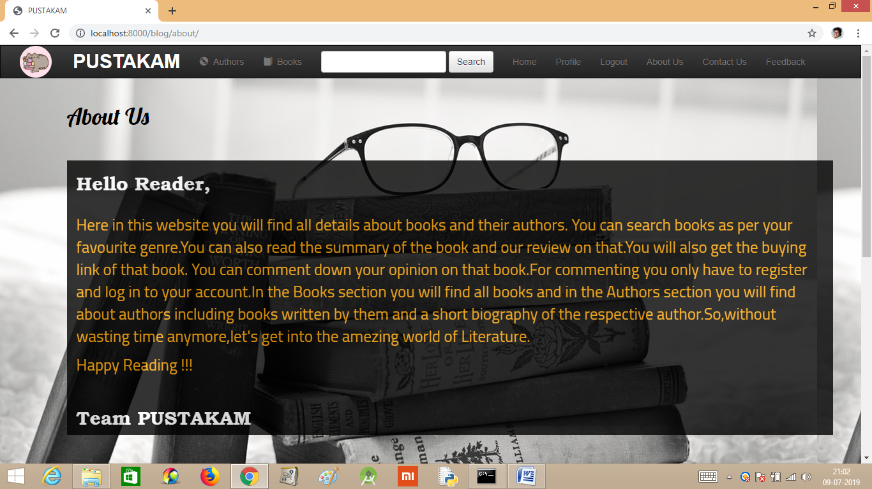

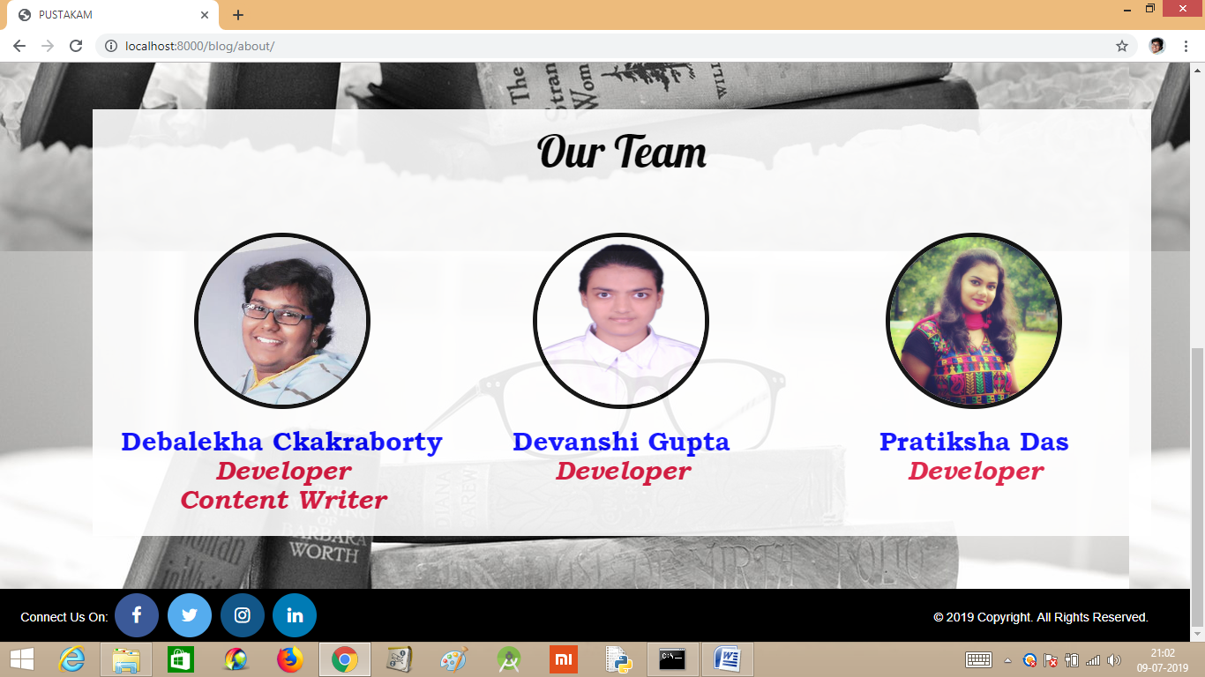

* GOING TO THE ‘CONTACT US’ FROM NAVIGATION BAR :

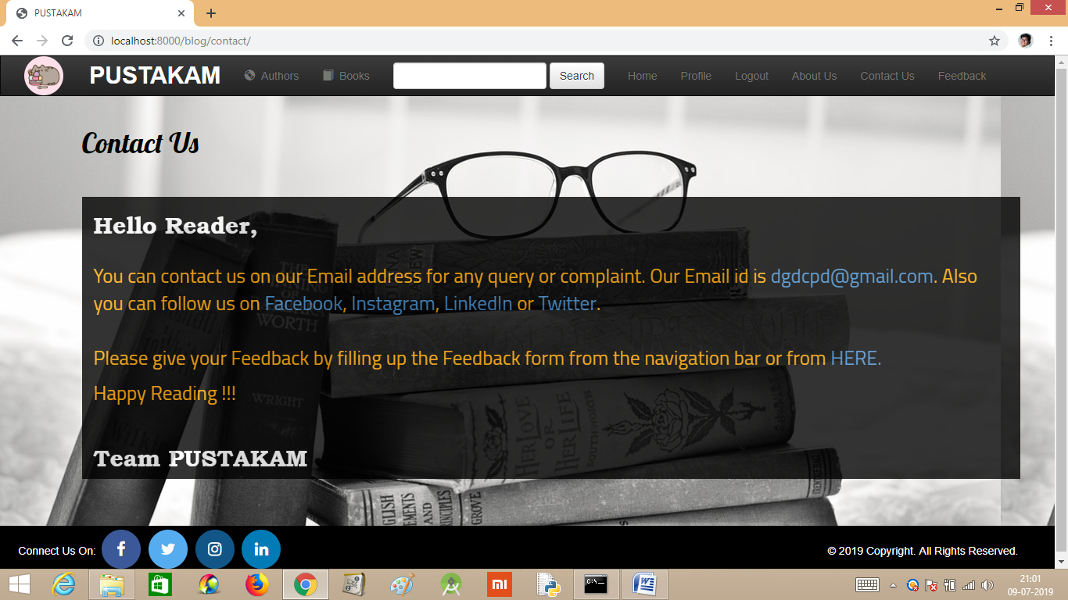

* GOING TO THE ‘LOGOUT’ FROM NAVIGATION BAR :



* GOING TO THE ‘FEEDBACK’ FROM NAVIGATION BAR :

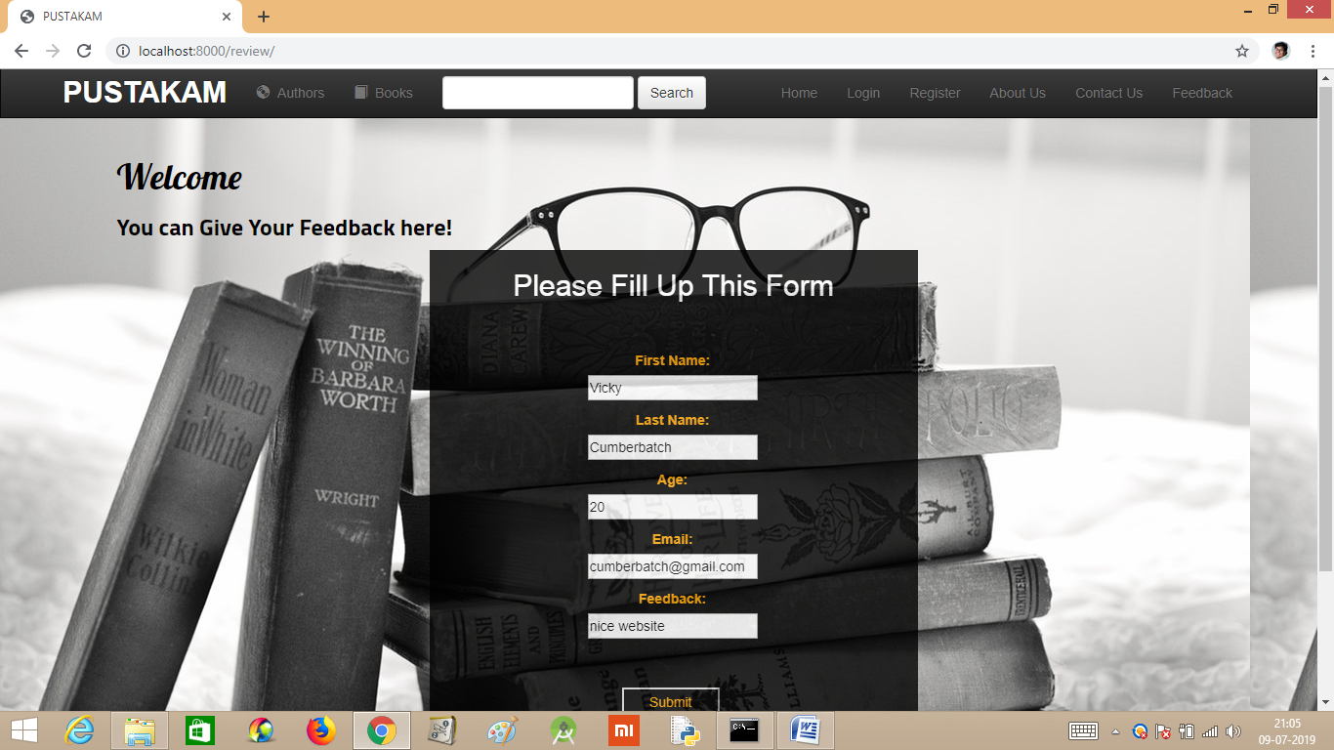

* CLICKING ON ‘SUBMIT’ OF THE FEEDBACK FORM :



**SNAPSHOTS 0F THE DIRECTORY**

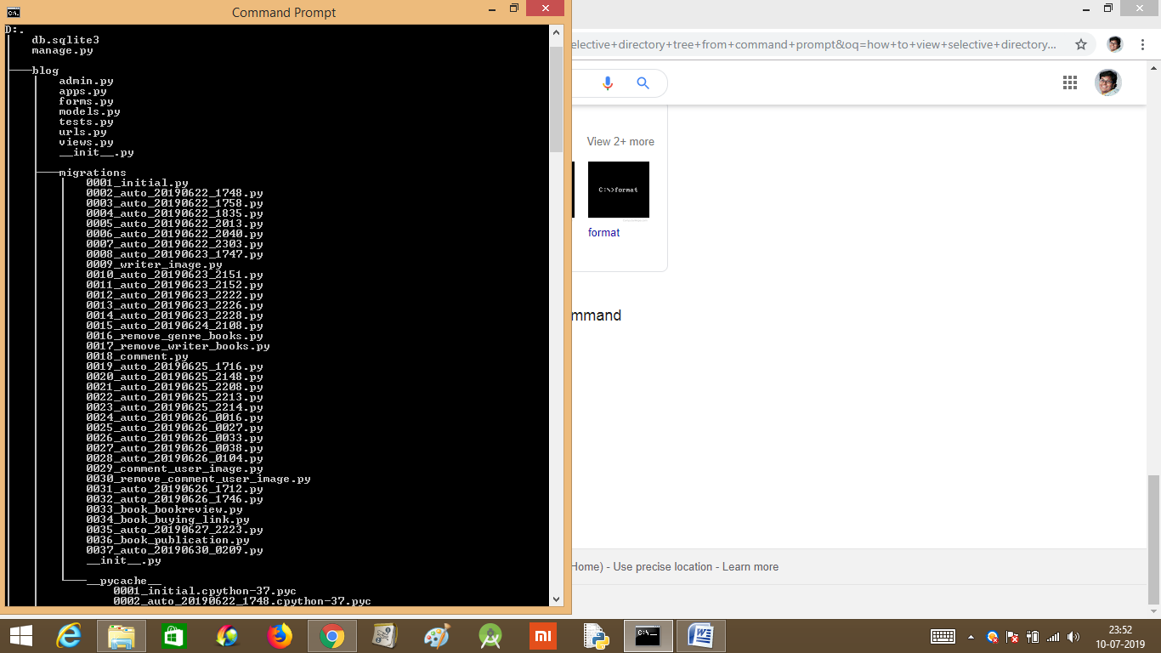

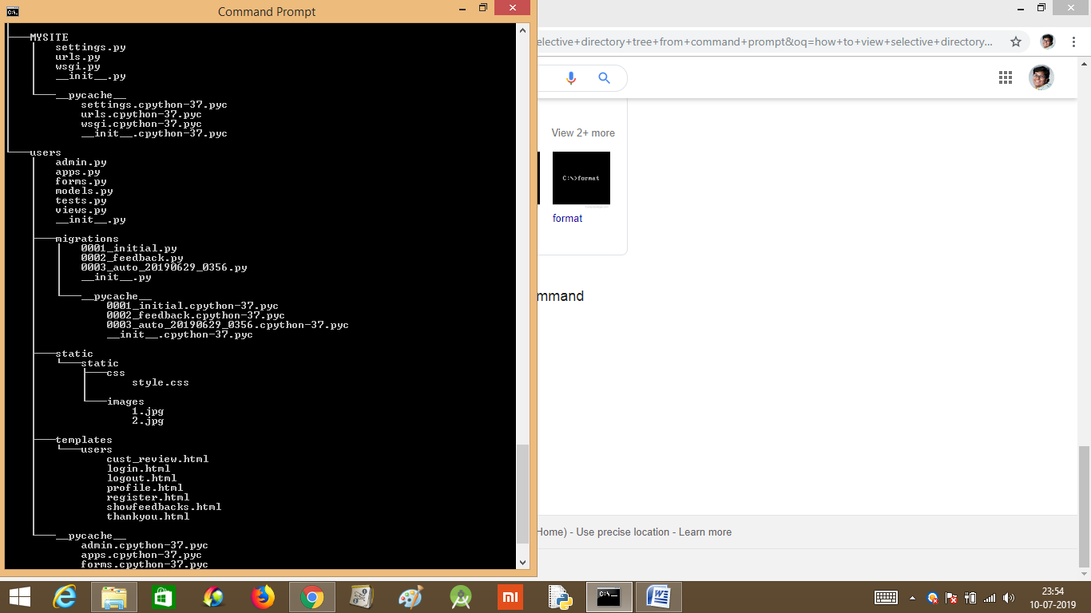

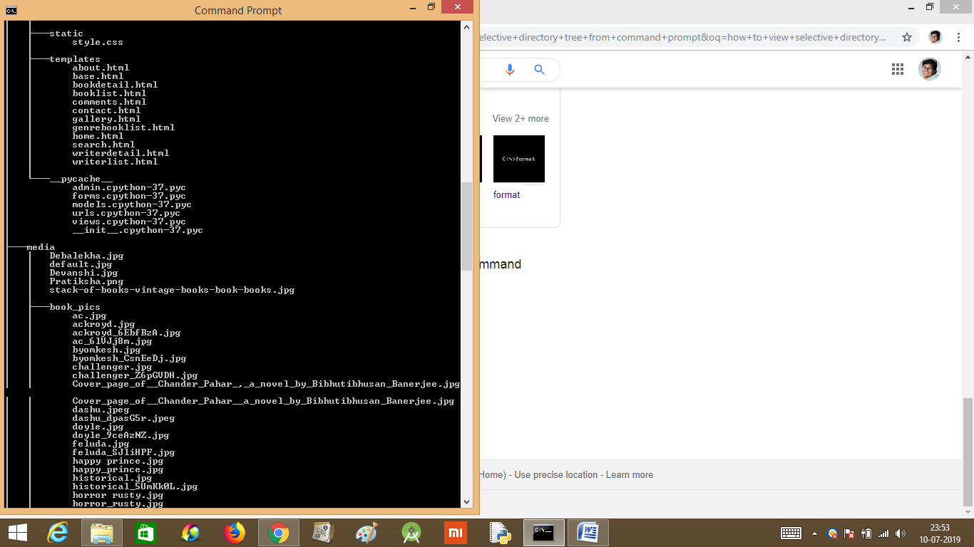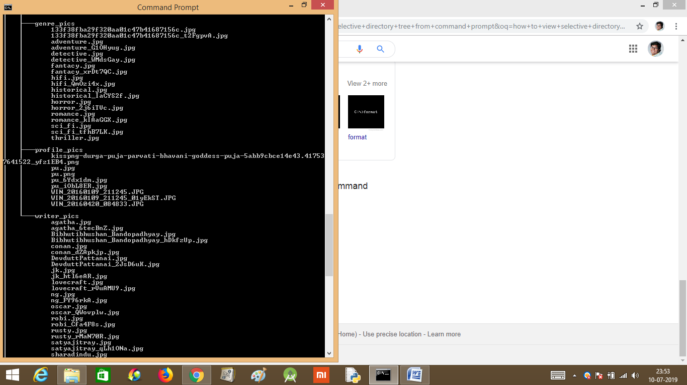

**CONCLUSION**

This website can be improved in future by many aspects. Posting access can be given to the users. The wish list can be added for each user. Follow list can be given to each author. Reply and editing option can be added in the comment section. The website can be launched globally by taking a proper privacy policy and copyright and purchasing a domain/host name.